**“My House” PIES HOW MANY?**

**Small (6”) Large (9”)**

**Apple Crumb $ 8.99 _______ $ 16.99 _______**

**Apple Caramel Walnut $ 8.99 _______ $ 16.99 _______**

**Apple Double Crust $ 8.99 _______ $ 16.99 _______**

**Apple Pear Cranberry $ 8.99 _______ $ 16.99 _______**

## **Coconut Custard $ 8.99 _______ $ 16.99 _______**

## **Key Lime $ 8.99 _______ $ 16.99 _______**

**Mixed Berry $ 8.99 _______ $ 16.99 _______**

**Peanut Butter Cup Pie $ 8.99 _______ $ 16.99 _______**

**Pecan $ 8.99 _______ $ 16.99 _______**

**Pecan Chocolate $ 8.99 _______ $ 16.99 _______**

**Pumpkin $ 8.99 _______ $ 16.99 _______**

**Sweet Potato Pie $ 8.99 _______ $ 16.99 _______**

**Vegetable POT PIE $ 8.99 _______ (small only)**

“My House” Baked Goods HOW MANY?

**1/2 lb. Fall Sugar Cutouts $ 6.99 _______**

**Carrot Cupcake $ 2.99 _______**

**1 lb. Carrot Cake $ 6.99 _______**

**2 lb. Carrot Cake $13.99 _______**

**“My House” QUICHE HOW MANY?**

**Small (6”) Large (9”)**

**Broccoli Cheddar $ 8.99 _______ $ 16.99 _______**

**Caramelized Onion & Butternut Squash $ 8.99 _______ $ 16.99 _______**

**Spinach & Feta $ 8.99 _______ $ 16.99 _______**

**Vegetable $ 8.99 _______ $ 16.99 _______**

**“Jes-Made” Breads HOW MANY?**

**Apple Fritter Bread $7.99 ________**

**Cranberry Bread $7.99 ________**

**Pumpkin Bread $7.99 ________**

**Chocolate Chip Bread $7.99 ________**

**German Butter Cake $8.99 ________**

“LeBus” BREADS HOW MANY? SLICED? ( YES or NO)

**Multi-Grain $ 7.49 ______ sliced?_______**

**Raisin Walnut $ 8.99 ______ sliced?_______**

**Italian $ 5.99 ______ sliced?_______**

**Country French $ 4.99 ______ sliced?_______**

**Rye $ 6.49 ______ sliced?_______**

**Seeded Rye $ 6.49 ______ sliced?_______**

**Marble Rye $ 6.49 ______ sliced?_______**

**Sour Dough $ 6.99 ______ sliced?_______**

**Oatmeal $ 7.49 ______ sliced?_______**

**Pumpkinseed $ 7.99 ______ sliced?_______**

**“Baker Street” DINNER Rolls HOW MANY?**

**Parkerhouse $ 3.49 _______ (1/2 dozen)**

**Sesame Honey $ 3.49 _______ (1/2 dozen)**

**Multi-grain $ 3.49 _______ (1/2 dozen)**

**French $ 3.49 _______ (1/2 dozen)**

**“Baker Street” Sandwich Rolls & Bread**

**Brioche Bun $ 5.89 _______ (1/2 dozen)**

**Brioche Onion Poppyseed Bun $ 5.89 _______ (1/2 dozen)**

**French Baguette $ 3.99 _______**

**Sesame Honey Loaf $ 6.99 _______ (sliced)**

**Multigrain Loaf $ 6.99 _______ (sliced)**

**“Abruzzi” Bread & Rolls HOW MANY?**

**Italian Baguette $ 3.99 ________**

**Italian Oblong $ 3.99 ________**

**Mini Italian Oblong $ 1.99 ________**

**Long Rolls $ 4.69 ________ (1/2 dozen)**

**Kaiser Rolls $ 4.69 ________ (1/2 dozen)**

**“Philly Bread” Philly Muffins HOW MANY?**

**Original $ 4.99 _______ (4-pack)**

**Hearty Wheat $ 4.99 _______ (4-pack)**

**Everything $ 4.99 _______ (4-pack)**

**Cinnamon Raisin $ 4.99 _______ (4-pack)**

NOTE: ALL BAKERY ORDERS MUST BE RECEIVED NO LATER Than SUNDAY, NOVEMBER 12th

Please neatly fill in all of the following:

#### NAME:__________________________

**PHONE NUMBER: (check PREFERRED number)**

**Cell:________________ Home:_______________**

**CHECK PICK-UP DATE**:

**_­­___Tuesday, Nov. 21st *OR ____*Wednesday, Nov. 22nd**

PICK-UP TIMES:

Tuesday: 10:00 – 6:00 PM

Wednesday: 10:00 – 6:00 PM

**IMPORTANT REMINDER:**

***Wolff’s will be closed on Thanksgiving Day,***

***Thursday Nov.* 23rd*!***

**PLEASE DROP YOUR COMPLETED ORDER FORM  
IN THE BAKERY ORDER DROP BOX**

**Wolff’s Apple House**

**81 South Pennell Road**

**Lima, Pa. 19037**

**(610) 566-1680**

***Have a Happy Thanksgiving!!***





Thanksgiving Bakery

Order Form 2017

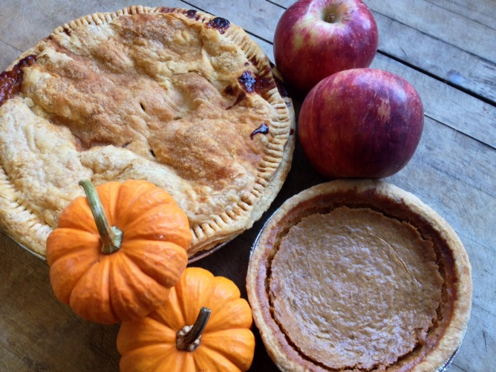

Wolff’s Hours:

Monday – Saturday 9 a.m. – 6:30 p.m.

Sunday 9 a.m. – 5:30 p.m.

Wolff’s will be Closed Thanksgiving

Thursday, November 23rd

REOPEN: Friday, Nov. 24th at 9:00 am